Model Development Phase Template

|  |  |
| --- | --- |
| Date | 15 July 2024 |
| Team ID | 739965 |
| Project Title | Market Segmentation Analysis |
| Maximum Marks | 4 Marks |

**Initial Model Training Code, Model Validation and Evaluation Report**

The initial model training code will be showcased in the future through a screenshot. The model validation and evaluation report will include classification reports, accuracy, and confusion matrices for multiple models, presented through respective screenshots.

**Initial Model Training Code:**

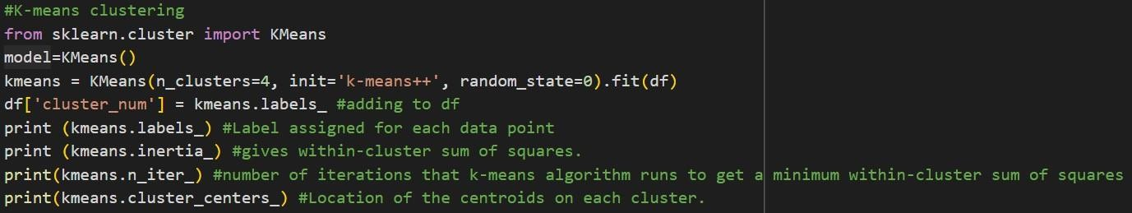

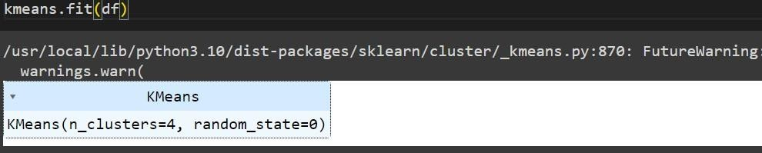

**Model Validation and Evaluation Report:**

|  |  |  |  |
| --- | --- | --- | --- |
| **Model** | **Classification Report** | **Accuracy** | **Confusion Matrix** |
| KMeans Clustering | - | - | - |